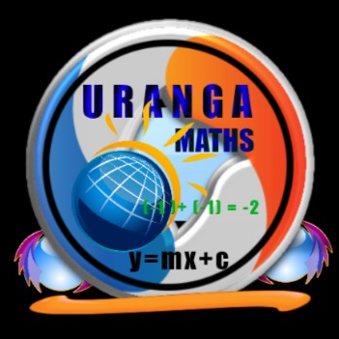

**Name…………………………………………………………… ADM Number:……………..**

**School:…...……….............................. Candidate’s Signature……………...…………..**

**121/1**

**Mathematics Alt.A**

**FORM TWO.**

**JULY 3RD 2024.**

**2 ½ Hours.**

**URANGA MATHEMATICS ASSOCIATION-2024.**

**Kenya Certificate of Secondary Education**

**MATHEMATICS 121/1**

**FORM TWO**

**TIME: 2 ½ HOURS**

**INSTRUCTIONS TO CANDIDATES:**

* Write your name, school, admission number and sign in the spaces provided above.
* This paper contains **TWO** sections: Section **I** and Section **II**.
* Answer **ALL** the questions in Section **I** and **FIVE** questions from section **II**.
* All answers and working **MUST** be written on the question paper in the spaces provided below each question.
* Marks may be given for correct working even if the answer is wrong.
* Non-programmable silent electronic calculators and KNEC Mathematical tables may be used, except where stated otherwise.

**FOR EXAMINERS USE ONLY**

**SECTION I**

|  |  |  |  |  |  |  |  |  |  |  |  |  |  |  |  |  |
| --- | --- | --- | --- | --- | --- | --- | --- | --- | --- | --- | --- | --- | --- | --- | --- | --- |
| **1** | **2** | **3** | **4** | **5** | **6** | **7** | **8** | **9** | **10** | **11** | **12** | **13** | **14** | **15** | **16** | **Total** |
|  |  |  |  |  |  |  |  |  |  |  |  |  |  |  |  |  |

**SECTION II**

**Grand Total**

|  |  |  |  |  |  |  |  |  |
| --- | --- | --- | --- | --- | --- | --- | --- | --- |
| **17** | **18** | **19** | **20** | **21** | **22** | **23** | **24** | **Total** |
|  |  |  |  |  |  |  |  |  |

*This paper consists of 15 printed pages. Candidates should check to ascertain that all pages are printed as indicated and that no questions are missing.*

**SECTION I (50 MARKS)**

**Answer ALL the questions in this section in the spaces provided.**

1. Without using mathematical tables, evaluate; (3 marks) 



1. Use reciprocals and cube tables to evaluate to 4 significant figures.  (3 marks)
2. A bank in Kenya buys and sells foreign currencies as follows.

|  |  |  |
| --- | --- | --- |
|  | buying (Ksh) | Selling (kshs.) |
| 1 Us dollar | 85.86 | 86.06 |
| 1 sterling pound | 142.41 | 142.73 |

A tourist from united States of America converted 43,521 US dollars into Kenya shillings.

* 1. Calculate the amount in Kenya shillings that she received (2mark)

(ii) While in Kenya, the tourist spent sh. 2437821 and converted the balance to sterling pounds. How much in

Sterling pound did the tourist receive to the nearest sterling pound? (2 marks)

1. Use the elimination method to solve the simultaneous equations

 (3 marks)



1. Use logarithms to evaluate. (4 marks)

$$\sqrt[4]{\frac{43.52 x 0.08792}{785.3}}$$

1. Using a ruler and a pair of compasses only, construct triangle ABC such that AB = 4 cm, AC = 8 cm and Measure BC. (3 marks)
2. Find the equation of the L1 in the form $y=mx+c$ which is perpendicular to the line 3y + 2x = 6 and passes through the point (-3, 4). (3 marks)
3. A saleswoman is paid a commission of 2% on goods sold over Ksh 100 000. She is also paid a monthly salary of Ksh 12 000. In a certain month, she sold goods worth sh 180 000. Calculate the saleswoman earnings that month. (3 marks)

1. Express  as a fraction leaving it in the form $\frac{p}{q}$ (3 marks)
2. Three alarms go off at intervals of 12 seconds, 18 seconds and one minute. At 6.30 p.m, the alarms went off simultaneously. Find the times when the three alarms go off simultaneously again in the next 10 minutes. (3 marks)

1. The surface areas of two similar bottles are 12cm2 and 108cm2 respectively. If the bigger one has a volume of 810cm3. Find the volume of the smaller one. (3 marks)
2. In the parallelogram ABCD below, AB = 12cm, BC = 10cm and Angle BAD = 1200. Calculate the area of the parallelogram. (3 marks)

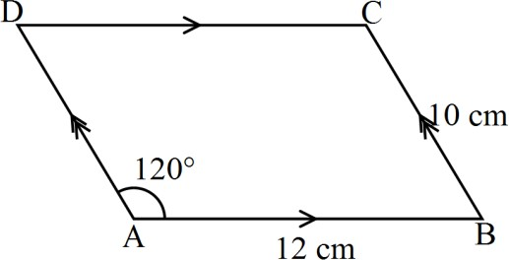

1. A piece of metal has a volume of 20cm3 and a mass of 300g. Calculate the density of the metal in kg/m3. (3 marks)
2. A triangular flower garden has its edges measuring 14 metres and 8 metres and 10 metres. Calculate

the area of the garden in m2. (3 marks)

1. Given that sin (x – 30)0 = Cos (4x) 0. Find x given that it is an acute angle. (3 marks)

1. The figure below is a prism whose cross-section is an equilateral triangle such that AB=BC=CA=3cm, BE=CD=AF=5cm

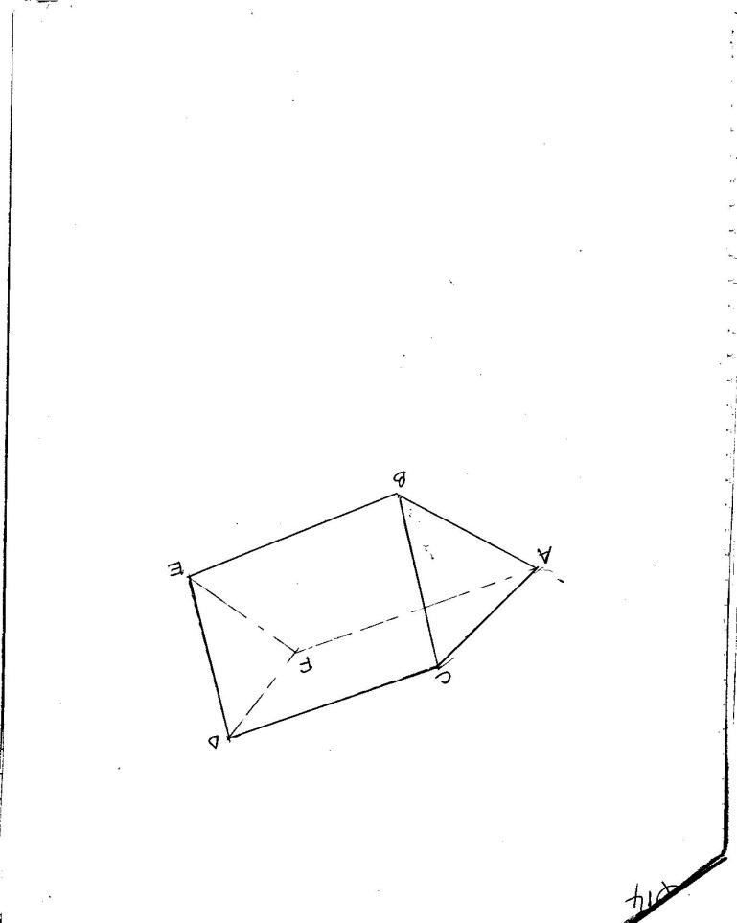

Draw the net of the prism (3 marks)

**Section II (50 Marks):**

**Answer ANY five questions in this section in the spaces provided.**

1. A plane leaves airport P for airport Q, 500 km away on a bearing of  It then flies to airport R 600km away on a bearing of  From R, it flies west to another airport S which is to the south of P.
2. Use a scale of 1 cm represents 100 km, draw a diagram showing the relative positions of the four airports. (4 marks)

1. Use the scale drawing to find the
2. Distance between airport P and airport R. (2 marks)

1. Bearing of R from P. (1 mark)

1. Distance and bearing of S from Q (3 marks)

1. A butcher bought a number of bulls and a number of goats at Ksh.15,500 per bull and Ksh.2,400 per goat spending a total of Ksh 43,000. If he had bought half as many bulls and twice as many goats he would have saved Ksh.3,500. He slaughtered all the animals and sold the meat at a profit of 30% per bull and 40% per goat. Determine
2. The number of bulls and the number of goats the butcher bought. (5 marks)

1. The percentage profit he made on all the animals giving your answer to one decimal place. (5 marks)

19. The table shows recordings from surveyors’ field book.

**B**

280

E 25 200

160 B 80

C 70 120

100 D 50

**A**

* 1. Draw a sketch diagram from the data in the field book (2 marks)
  2. Given that the recordings are in metres, determine the area of the land in hectares.

(8 marks)

20. a) The figure below represents a model of a hut whose base ABCD is a square of side 10cm, AE = 15cm and EV = 13cm.

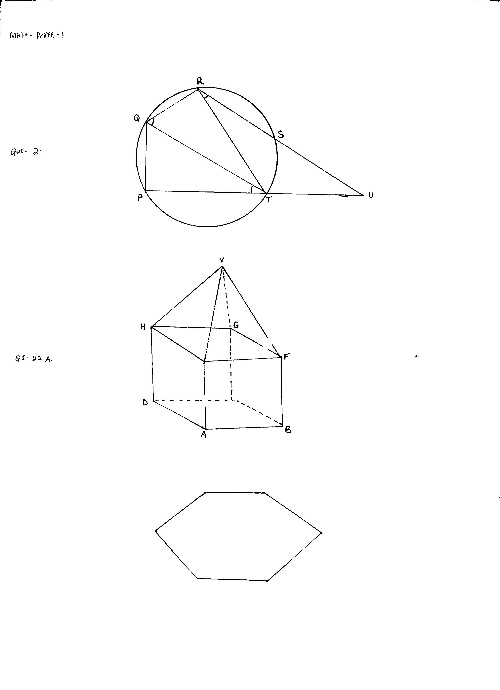

10cm

15cm

10cm

E

C

13cm

Calculate the total surface area of the solid. (5 marks)

b) The cross section of a prism consists of a regular hexagon of sides 4.8cm as shown in the figure

below.



4.8cm

i) Calculate the area of the cross-section. (3 marks)

ii) If the prism is 10.5cm long. Calculate its volume. (2 marks)

21. In the figure below, O is the centre of the circle of radius 3cm and AB is a chord such that its shortest

distance from O is 1cm.

O

3cm

1cm

A B

Calculate:-

(a) The length of the chord AB. (2 marks)

(b) The angle AOB (3 marks)

(c) The area of the minor sector OAB. (2 marks)

(d) The area of the shaded segment. (3 marks)

22. The figure shows a frustum of a right pyramid open container for storing water.

20cm

40cm

60cm

10cm

20cm

Calculate:

a) The height of the pyramid from which the frustum was cut from. (2 marks)

b) The capacity of the frustum in litres. (4 marks)

c) The surface area of the frustum. (4 marks)

23. The equation of a straight lineis given as $y= -\frac{2}{3}x - \frac{2}{3}$**.** The line meets the x – axis at point T.

(a). Determine the coordinates of T. (2 marks)

(b). A second line L2 is perpendicular to line L1 at T. Find the equation of line L2 in the form 𝑎𝑥 + 𝑏𝑦 = 𝑐 where a, b and c are constants**.** (3 marks)

(c). A third line L3 passes through (−4,1) and is parallel to L1. Find;

The equation of line L3 in the form 𝑦 = 𝑚𝑥 + c (2 marks)

(d).The coordinates of point S at which L3 intersects L2. (3 marks)

24. The coordinates of ∆ ABC are A (-1, 1) B (-5, 2) and C (-3, 5). The image of ABC under a

rotation has coordinates A’ (1, 1), B’ (2, 5), C’ (5, 3)

a) Plot ABC and A’B’C’ on same grid. (2 marks)

b) By construction find the centre and angle of rotation that maps ABC on to A’B’C’. (3 marks)

c) A’’B’’C’’ is the image of A’B’C’ under a reflection on the line x-y =0. Plot A’’B’’C’’ and

write down its coordinates. (3 marks)

d) A’’’ B’’’ C ’’’ is the image A’’B’’C’’ under an enlargement centre the origin and

scale factor – 1. Draw A’’’ B’’’ C ’’’ on the same grid. (2 marks)

